

Here we have a query of all returns. The pie-chart below displays percentages of each product based on the total count of **37, 981**.

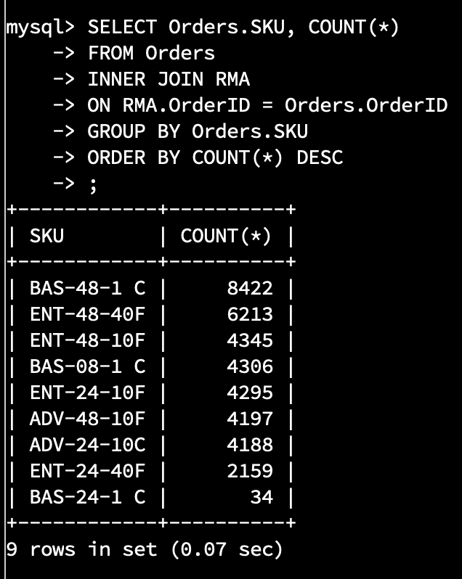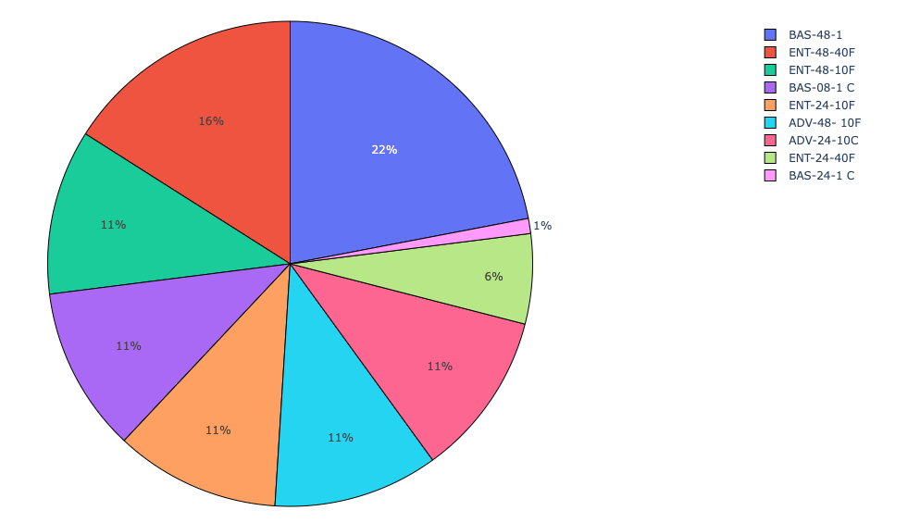

We will focus on the top 3 items being returned. Products **BAS-48-1,** **ENT-48-40F**, and **ENT-48-10F** A total of **18,980** returns accounting for 49% of all returns.

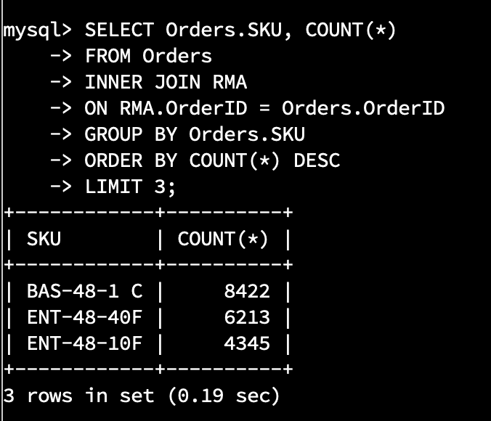

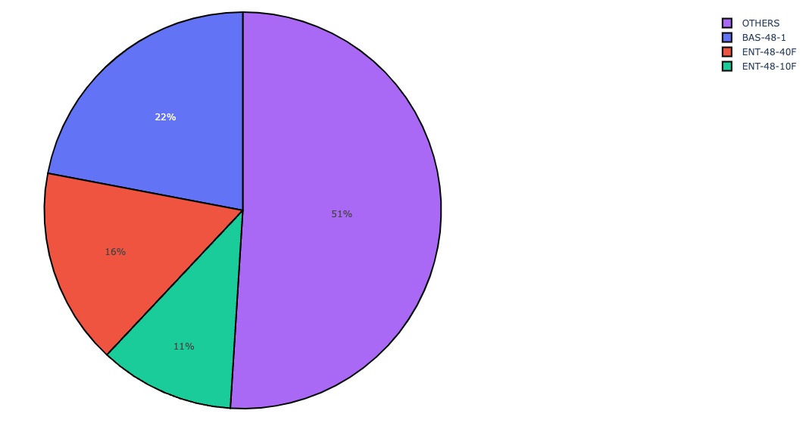

**Product:** **ENT-48-40F**

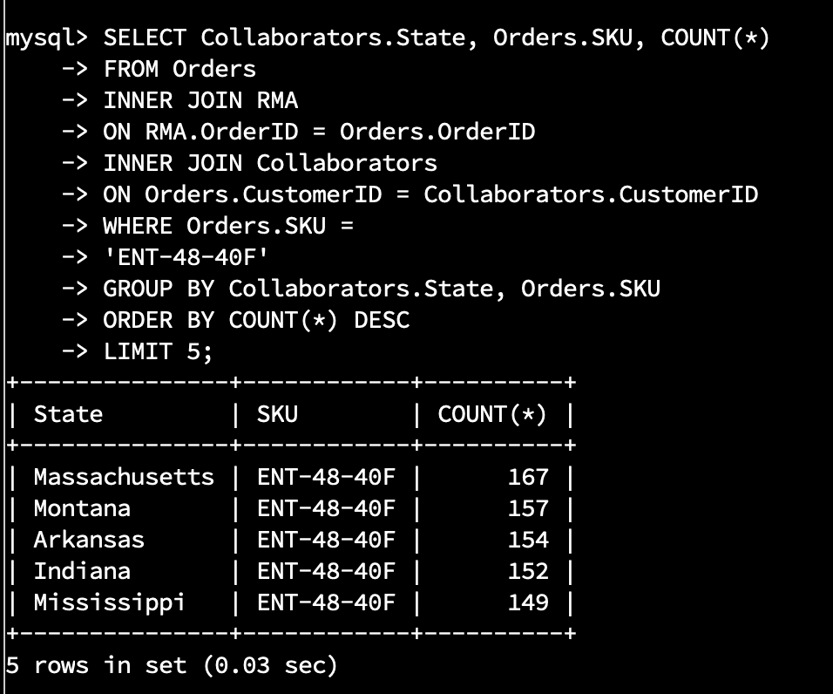

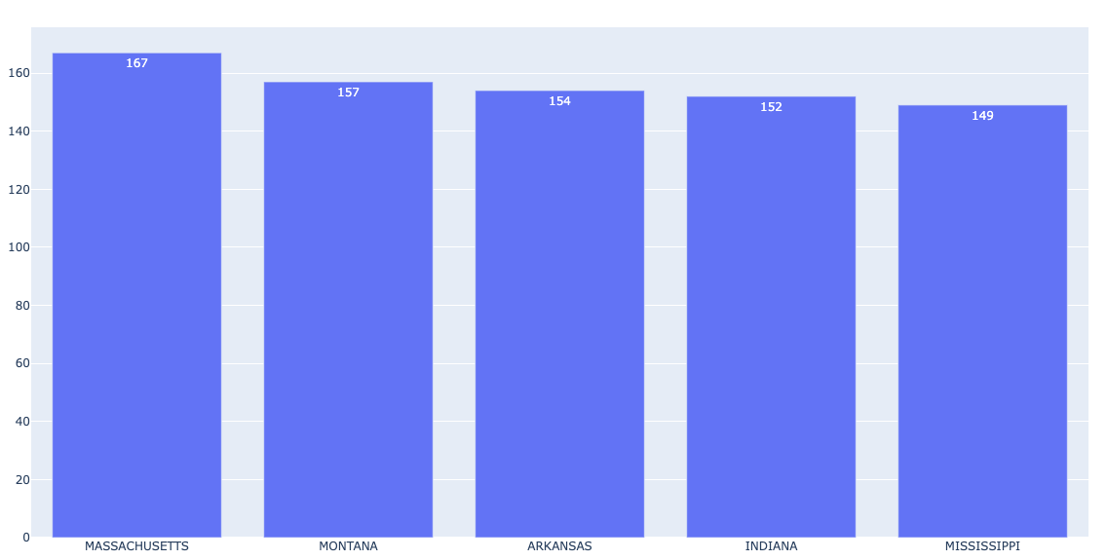

**Product:** **ENT-48-10F**

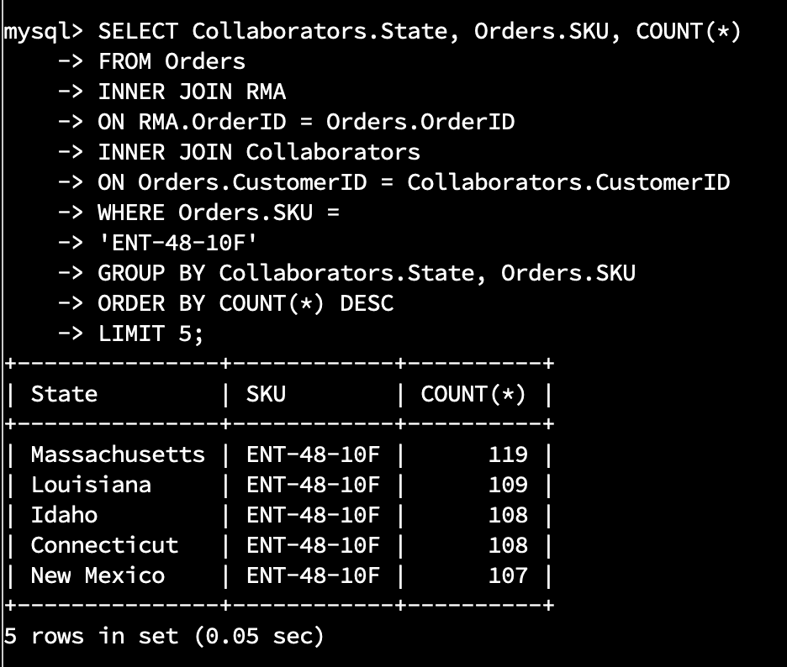

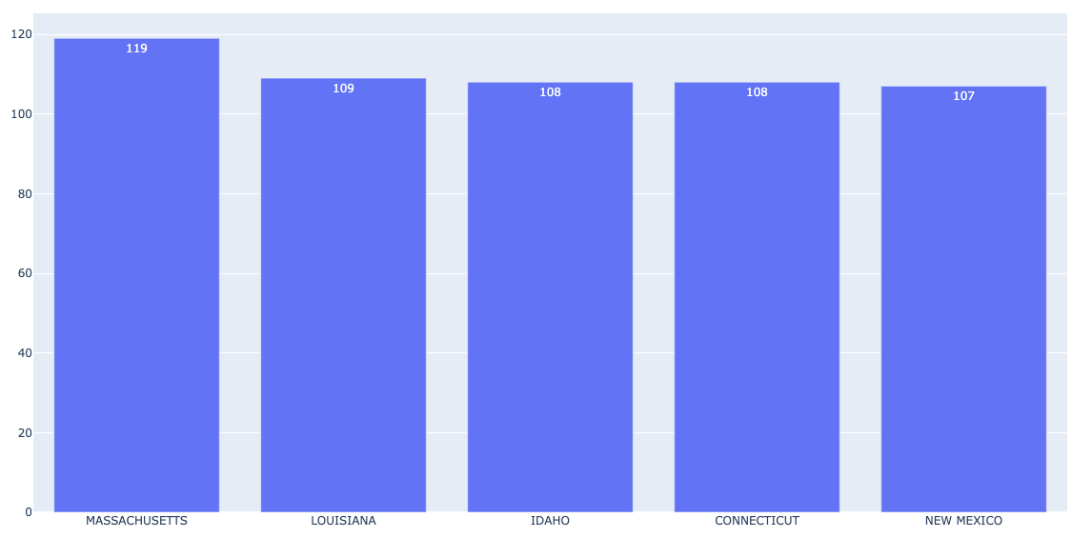

**Product:** **BAS-48-1 C**

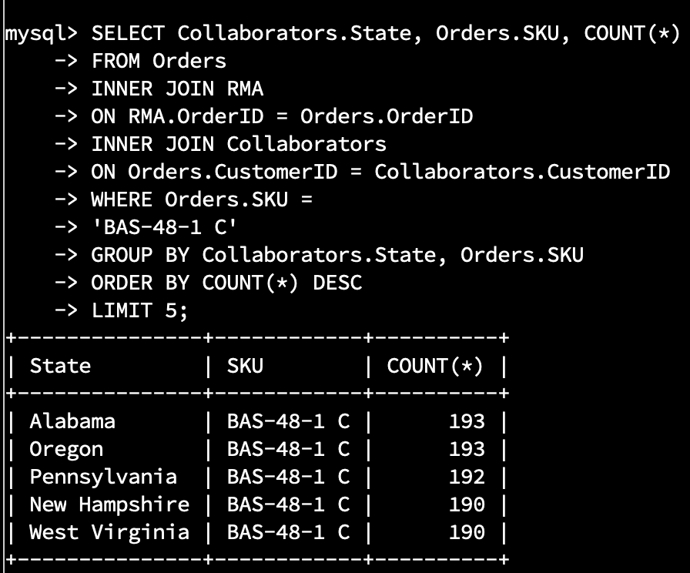

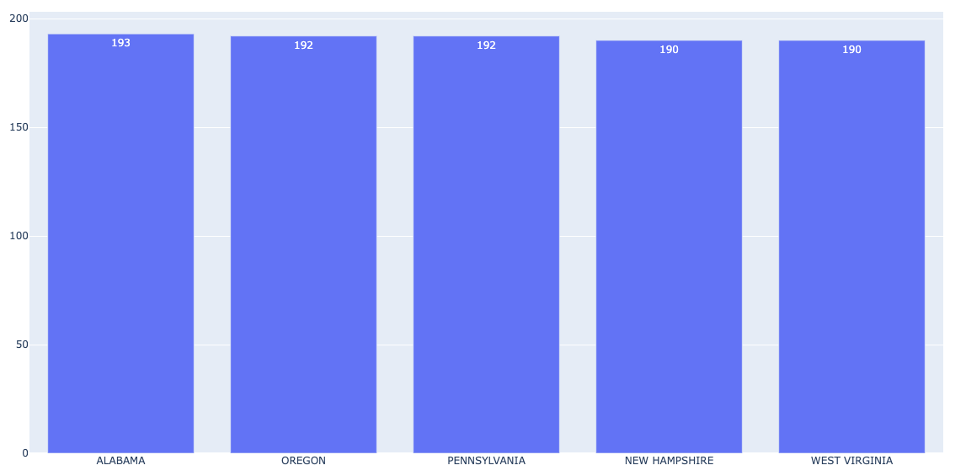

**Analysis**

The aforementioned data provides a detailed view of the company’s product performance.

It’s apparent that products **BAS-48-1** and **ENT-48-40F** are not performing well, as they constitute 22% of our inventory and 38% of our returns. **BAS-48-1** and **ENT-48-40F** are being returned at 22% and 16%, respectively. We will need to work on the quality of these products to reduce the rate of return or consider discontinuing them.

Products **ENT-48-10F**, **BAS-08-1 C**, **ENT-24-10F**, **ADV-48-10F**, and **ADV-24-10C** are each being returned at a rate of 11%. This is closer to an acceptable rate of return (5%-10%) but still not ideal.

In contrast, our most profitable products are **ENT-24-40F,** which is returned at 6%, and **BAS-24-1 C**, our most successful product and only accounts for 1% of the company's returns. These numbers are both acceptable and profitable to the company.

As for the geographic data in reference to the three products being returned the most (**BAS-48-1**, **ENT-48-40F**, **ENT-48-10F)**, a query was run to track the top 5 states for each of the three products. This query did not detect a specific area of the country that had an accumulation of returns, as only one state, Massachusetts, appeared more than once (exactly twice) in the three queries. We can surmise that the return rate for these products is based more on the products themselves and not the region in which they’re sold.